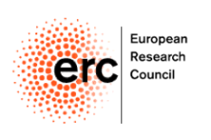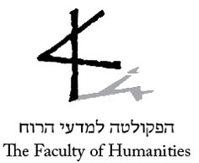

CALL FOR PAPERS

Second International Workshop
ERC Project “JudgingHistories”
Professor Dan Diner, Principal Investigator

The Indian Predicament:
South Asia in WWII

June 5-6, 2016
The Hebrew University of Jerusalem
Mt. Scopus

The 2nd international workshop of the ERC Project “Experience, Judgement, and Representation of World War II in an Age of Globalization” aims to historicize WWII and its memory in the Indian subcontinent. British India was pivotal to the Empire’s and the Allies’ war efforts, and was profoundly shaped by the war. Yet, save for a few exceptions, e.g. Voigt (1978), Kamtekar (2002), Bayly & Harper (2004, 2007), and Khan (2015), WWII has been a marginal subject in Indian historiography, occluded by the grand themes of the transfer of power and the partition of India. Our workshop seeks to build upon existing literature and further develop a research agenda that would bring the war center stage.

Broadly speaking, we ask how WWII could be situated, both diachronically—in relation to India’s history prior to the war and its decolonization afterward, and synchronically—vis-à-vis the global war situation. We hope that by combining synchronic and diachronic approaches we could start addressing the epistemological and moral questions concerning comprehension, memory and judgement of the event as a historical watershed. We would like to ask what were the lenses through which historical actors made sense of the war as it unfolded, how colonial history and nationalist struggle prior to the war might have shaped this comprehension, and how such real time perceptions filtered into postwar memory (or forgetting), and moral judgement of the war.

Accordingly, the workshop will be organized chronologically, beginning with papers that address the prewar years (from the 1930s), through the war period, to the postwar period of decolonization. We invite papers that address iconic events and key themes. These may include, but are not limited to:
- Fall of Singapore
- Indian soldiers in different war theatres
- Subhas Chandra Bose and the INA
- India’s role in the imperial and allied logistics
- Quit India Movement
- Bengal famine
- INA trials
And further subjects of interest.

Paper proposals should include a title, an abstract (not exceeding two pages), institutional affiliation and contact information. Please submit proposals to judghist@mail.huji.ac.il by February 1, 2016.

Suitable participants will be contacted and will be kindly asked to send a full version of their paper by May 16, 2016. The papers will be pre-circulated in order to facilitate an engaged discussion during our workshop.

Travel costs (economy) and the costs of accommodation in Jerusalem (3 nights) will be covered for all workshop participants from abroad.

Workshop participants may be invited to submit their presentations for publication in the project’s publication series “JudgingHistories”.

With best wishes,
Dr. Rotem Geva
Postdoctoral Fellow
ERC Project “JudgingHistories”

