Placing Conrad: Space and Geography in Conrad’s Fiction
A Symposium
9:15am–6pm, Saturday 17th February 2018 | Room G35, Senate House, Malet Street, London
Funded generously by the MHRA and Northumbria University’s Institute of the Humanities

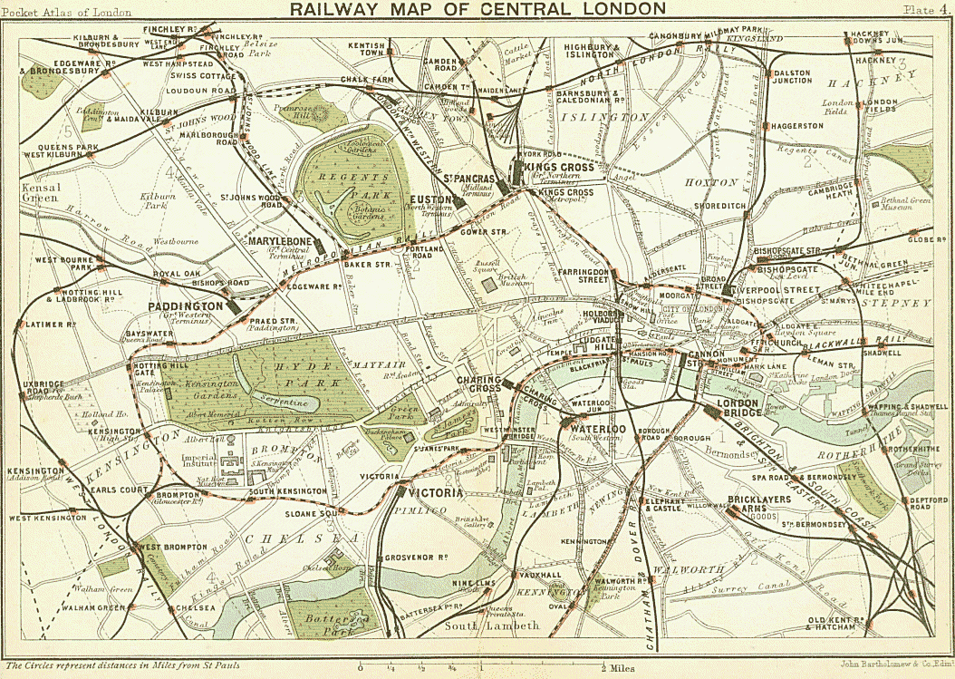
Welcome (9:20am)
Plenary Session 1: Conradian Geography (9:30-11am)
Dr Katherine Isobel Baxter – Geography and Law in Conrad’s Fiction
Dr Andrew Glazzard – The Psychogeography of Conrad and Conan Doyle’s London
Dr Johan Warodell – “Tinkle tinkle pinnnng”: Mapping Speech in Conrad
Tea and Coffee (11-11:30am)
Plenary Session 2: Explorations in the Space-Time Continuum (11:30-1pm)
Professor Linda Dryden – Conrad, Ford, Wells and The Inheritors: Exploiting the Fourth Dimension
Dr Stephen Donovan – Interplanetary Conrad
Dr Teng Hong-Shu – The Strange Conrad Novel in Ian McEwan’s Saturday: Joseph Conrad and the Responsibility of Place
Lunch (1-1:45pm)
Plenary Session 3: Experiential Space in Conrad’s Fiction (1:45-3:45pm)
Dr Yael Levin – Wrong Place, Wrong Time: Spatial Refrains in Lord Jim and “Amy Foster”
Dr Nic Panagopoulos – Traversing Space/Time with the Mind's Eye: Conrad, George Eliot, and the Lifted Veil
Dr Patricia Pye – “With Questions and Answers Approved by the Author”: Conrad in the space of the classroom
Professor Susan Jones – Space and Gesture in Conrad’s Fiction
Tea and coffee (3:45-4:15pm)
Keynote (4:15-5pm)
Iain Sinclair in conversation with Professor Andrew Michael Roberts.
Reception (5-6pm)
This event is free but please contact katherine.baxter@northumbria.ac.uk to register
